**SAMANTA’S YANTRA’S**

**Abstract**

This project intends to the preservation of the Equipments made by Pathani Samanta (Samanta Chandrsekhar), for the purpose of naked eye, astronomical observations. Precisely this project will delv deeper into the mathematics and construction of these yantras, and find out various ways to make them compact, available and carriable, so that it can be mass produced and every school students can afford to use it.

**Basic Information about Samanta Chandrasekhara**

Samanta Chandra Sekhar (1835-1904), popularly known as Pathani Samabta in Orissa, worked in astronomy following traditional methods, completely unaware of the telescope and other aids developed in the west. He took observations with ingenious and handy instruments, all fabricated by himself. His study and observations are recorded in an invaluable classic, the Siddhanta Darpana, composed in beautiful metrical Sanskrit verse. It contains many original contributions of Sumanta in observation, calculation, instrumentation, theory and model. Hence it shows appreciable improvements over the earlier classics like Surya Siddhanta and Siddhanta Siromani. The results of Chandra Sekhar’s observations are often comparable with modern data and his predictions in positional astronomy are in fair agreement with actual occurrence of astronomical events, even today. In view of all these, Samanta Chandra Sekhar stands out as a great naked eye astronomer who had reached the limit of accuracy in observation. The aim of this paper is to bring out the importance, improvise and fabricate most of the equipments used by Samanta Chandrasekhara, and make a strategy for its mass production so that it can be available for every school student.

**First Basic Information about the Equipmet (Yantra’s):**

**Mānayantra**: It is a T-shaped instrument made of two sticks, one standing vertical to the other. Former one got holes or marks in each unit. The observer can determine the height and distance of a distant object simultaneously by observing the object inside those holes taking two readings from different positions. This is the instrument which made Samanta popular among the On the time measurement units and measuring instruments common people of Odisha since its working principle is very simple based on rudimentary geometry.

**Golayantra**: It is a replica of earth surrounded by the sky. In other words it represents a globe surrounded by the celestial sphere. As we know the globe is used to locate a place on the earth through imaginary latitude and longitude lines on it. Similarly imaginary lines are drawn across celestial sphere to determine position, motion and their respective rising and setting times of heavenly bodies throughout the year.

**Suryaghadi**: It was fabricated by Samanta Chandra Sekhar and its model version was installed by Prof. Jogesh Chandra Roy in Ravenshaw College (now Ravenshaw University). Although it is later replaced by different people it has been showing correct local time even now and attract people of different parts of globe.

**Chapayantra**: It gives informations on time, date and month.

**Golardha Yantra**: It was designed by Samanta by using the lower part of the circular water pot and a stick of length equivalent to the radius of the pot inserted vertically upward at its center. This shows equally accurate time as the other sundials.

**Chakrayantra**: It is also a Sundial fabricated by Samanta following the similar principle of parallel axis to axis of rotation of earth and plane parallel to the equatorial plane. **Swayambahayantra**: It is an instrument consisting of a container filled with water and an indicator plate connecting with a pot floating on the water. Continuous evacuation of water with a constant rate indicates constant time interval in the indicator plate. Samanta was keeping this instrument all the time with him, since it can work in both day and night time independent of sky conditions (whether cloudy or clear, sunny or night).

**Manayantra**

**Geometry for the creation of these equipments**

Samanta made Mánayantra out of a stick 42 digits long, attaching a crosspiece of 4.5 digits to one end. The trigonometrical functions of sines and cosines were all committed in his mind.

Manayantra was one of the euipments that has made Samanta the public figure in Odisha. He could corectly esstimate the heights of distant objects with the Mnyantra. The calculations for every equipment was done manually, and Samanta did all the calculations in his memory.

Let us assume two unequall pieces of wood, AB and OC

A

B

O

C

Now also as in the figure AO is not equal to BO

Here the Vertical Rod OC consists of small holes, facing the

horizontal arms at equal intervals. A rider could be moved on

the vertical groove making one single hole at a disered position.

Working:

hold the arm AOB (as in the figure on the cover) parallel to the ground and look through the hole on the vertical arm keeping one end of the horizontal bar, the hole and tip of the object in a straight line. Position of the hole on the vertical arm is noted. Such coincidence may come often in between two holes. In that case, the vertical reading with a paper snip is noted. For another reading one has to move backward in a straight line some 20, 50, 100, or 500 feet, as the need may be. One has to move longer distance for farther objects. Then with the instrument again asimilar reading is taken and position of coincidence on the vertical scale is noted. From these observations both height and distance can be computed.

**Mathematics involved in the creation of these equipments**

Let b1, be the length of the horizontal arm from the fixed position O to an end. Let p1 and p2, be the heights on vertical arm marking coincidences in the first, let d be the distance moved and second reading. So from similar triangles we will have,

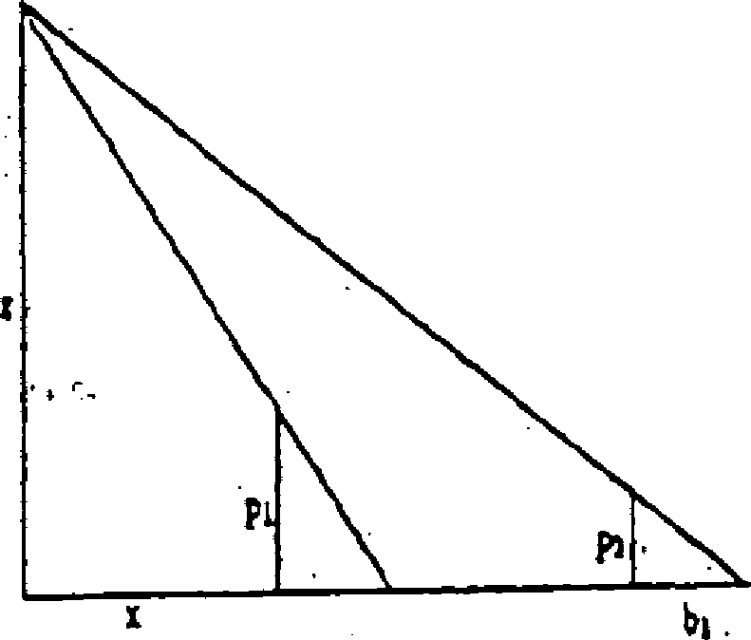

z/p1 = (x + b1)/ b1 and

z/p2 = (x + d + b1)/b1

where z and x are respectively the height and distance of the object. Neglecting b1 compared to x and (x + d) one gets,

z/p1 = x/b1 and

z/p2 = (x + d ) / b1

These equations when solved gives,

X = d / [(p1 / p2) - 1] and z = (p1 / b1) * d/[( p1 / p2 ) - 1]

**Ways to make these eqipments handy**

Keeping all the ratios same we can reduse the size of the Manayantra hugely, making it carriable.

Solution 1:

As we saw the formulas involved will not change the construction if we change the magnitude of the variables.

So, we can easily decrease the length of each rod, keeping the ratio same. The same goes for the holes in the vertical rod as well.

Solution 2:

Another way to make a big size Manayantra but easily carriable is to make it foldable.

First is to find the pivot points where the hinges would be attached.

In a Manayantra,

The joint of the two rods can be attached with a hinge, such that the vertical Rod becomes movable in one way.

There will be a stopper and lock system attached on both sides to make it stable while taking the observations.

Then the long horizontal Rod will be liased with a hinge and a stopper and lock system at somewhere the middle, making it foldable and decrease the size to minimum.

By this way we can have a big sized Manayantra in a small pouch.

**Report on the Work**

1. At the initial phase the team was intriduced to each other
2. Visited a few place like the preservation center for Old Books
3. Met with an excelent Proffessor at Srujanika, where we discussed a varied range of topics including the ones for space, cosmology, and Astronomy. It also included the topics of Star Gazzing and best telescopes that could be used to serve the purpose.
4. Next few days were the individual online research work, where I was able to find a lot of resources including the Siddhanta Darpana, although some documents needed a deep search to get there access.
5. With the great help of the university IKS team, we went to the Pathani Samanta Planeterium to find more resources regarding the project.
6. In the Planeterium we met with one of the talented proffessors, who instructed us very well about the project. And also gave us the suggestion for some of the books that would help in the project.
7. We were also able to convince him to take a session on Astronomy for all the students of the institution.
8. Finally drafted a first document cum report including the research work for one of the Pathani Samanta’s equipment, i.e. Manayantra, and will continue to add the data for all the other equipments as well.

**Certain Important Tasks done while the research work:**

To site the problems of the ancient mathematics

Find about all the equipments and delve deeper in the construction of them

Search for the history of Samanta Chandra Sekhar

Make a repository for the progress and upload all the files involved.

Create innovative solutions to make these equipments compact and pocket sized.

Analyse The **“Siddhanta Darpana”** Properly

**References:**

1. <https://www.ias.ac.in/public/Volumes/reso/005/07/0088-0091.pdf> (Indian Mathematics and Astronomy: Some Landmarks)
2. P C Naik and L Satpathy, Current Science, 69(8), 705 (1995)
3. P C Naik, Current Science, 89(1), 211 (2005)
4. Mahamahopadhyaya Shri. Chandrasekhar Singh Harichandan Mohapatra Samanta , Sidhanta Darpan (Dhramagrantha Store Publication, Cuttack, 1975)
5. odiabibhaba ([here](https://odiabibhaba.in/wp-content/uploads/book/bookview_en.php))